**SIES COLLEGE OF ARTS, SCIENCE & COMMERCE (AUTONOMOUS)**

**SION (W), MUMBAI-22**

**DEPARTMENT OF INFORMATION TECHNOLOGY**

**SYBSc(IT), SEMESTER IV**

**INTERNAL PROJECT**

For the Subject

**Core Java**

Title of the Project : **JTabbedPane**

Submitted by

1. Mange Vivek Jitendra – SIT2324029

2. Sahu Kanhucharan Danardan- SIT2324047

3.Sharma Abhinandan Rajkishor – SIT2324051

4.Taleti Sujal Ravi – SIT2324060

**For the Academic Year**

**2023-2024**

**TABLE OF CONTENTS**

|  |  |  |
| --- | --- | --- |
| **Sr.No** | **Contents** | **Pg.No** |
| I | Details of the Component | 3 |
| II | Event Details | 6 |
| III | Java Code | 7 |
| IV | Snapshots of the Code Output | 16 |

**I. Details of the component**

**Classname:-** JTabbedPane

## Hierarchy:-

* [java.lang.Object](https://docs.oracle.com/javase/8/docs/api/java/lang/Object.html)
  + [java.awt.Component](https://docs.oracle.com/javase/8/docs/api/java/awt/Component.html)
    - [java.awt.Container](https://docs.oracle.com/javase/8/docs/api/java/awt/Container.html)
      * [javax.swing.JComponent](https://docs.oracle.com/javase/8/docs/api/javax/swing/JComponent.html)
        + javax.swing.JTabbedPane

**About the component:-** A component that lets the user switch between a group of components by clicking on a tab with a given title and/or icon.

Tabs/components are added to a TabbedPane object by using the addTab and insertTab methods. A tab is represented by an index corresponding to the position it was added in, where the first tab has an index equal to 0 and the last tab has an index equal to the tab count minus 1.

The TabbedPane uses a SingleSelectionModel to represent the set of tab indices and the currently selected index. If the tab count is greater than 0, then there will always be a selected index, which by default will be initialized to the first tab. If the tab count is 0, then the selected index will be -1.

**Constructors(5)**

**1)JTabbedPane()**

Creates an empty TabbedPane with a default tab placement of JTabbedPane.TOP.

Eg :- public void JTabbedPane()

JTabbedPane tp = new JTabbedPane();

**2)JTabbedPane(int tabPlacement)**

Creates an empty TabbedPane with the specified tab placement of either: JTabbedPane.TOP, JTabbedPane.BOTTOM, JTabbedPane.LEFT, or JTabbedPane.RIGHT

Eg:-public void JTabbedPane(int tabPlacement)

JTabbedPane tp = new JTabbedPane(JTabbedPane.BOTTOM);

**3)JTabbedPane(int tabPlacement, int tabLayoutPolicy)**

Creates an empty TabbedPane with the specified tab placement and tab layout policy.

Eg:- public void JTabbedPane(int tabPlacement, int tabLayoutPolicy)

JTabbedPane tp = new JTabbedPane(JTabbedPane.TOP, JTabbedPane.WRAP_TAB_LAYOUT);

**4) JButton()**

Creates a button with no set text or icon.

Eg:- public void JButton()

JButton button = new JButton();

**5)JButton(String text)**

Creates a button with text.

Eg:- public void JButton()

JButton button = new JButton("Click me");

**Methods (5)**

1.**addTab(String title, Component component)**

This method is used to add a new tab to the tabbed pane with a given title and component.

Eg :- public addTab(String title, Component component)

tabbedPane.addTab("Tab 1", panel1);

2. **removeTabAt(int index)**

This method removes the tab at the specified index.

Eg:-public removeTabAt(int index)

tabbedPane.removeTabAt(2);

3. **setIconAt(int index, Icon icon)**

This method sets the icon of the tab at the specified index.

Eg :- public setIconAt(int index, Icon icon)

tabbedPane.setIconAt(1, new ImageIcon("icon.png"));

4. **removeALL()**

This method removes all tabs from the JTabbedPane

Eg :- public removeALL()

 tabbedPane.removeAll();

5. **setTitleAt(int index, String title)**

This method sets the title of the tab at the specified index.

Eg:- public setTitleAt(int index, String title)

tabbedPane.setTitleAt(0, "New Tab 1");

**II. Event details**

**User’s Activity :-** Visiting and enrolling online courses using different Tab

**Event class :-** ChangeEvent

**Event Listener :-** ChangeListener

**Methods to be implemented :-** public void stateChanged(ChangeEvent e)

Eg :-  tabbedPane.addChangeListener(new ChangeListener() {

            public void stateChanged(ChangeEvent e) {

              JTabbedPane pane = (JTabbedPane) e.getSource();

              int index = pane.getSelectedIndex();

              JOptionPane.showMessageDialog ("Tab changed to: " + pane.getTitleAt(index));

            }

          });

**III. Java Code**

import java.awt.*;

import java.awt.event.*;

import javax.swing.table.DefaultTableModel;

import javax.swing.*;

import javax.swing.event.*;

public class Home1 extends JFrame {

    private static final long serialVersionUID = 1L;

    private JPanel contentPane;

    private JTable table_2;

    public static void main(String[] args) {

        Home1 frame = new Home1();

        frame.setSize(1200, 900);

        frame.setVisible(true);

    }

    public Home1() {

        getContentPane().setLayout(null);

        JTabbedPane tabbedPane = new JTabbedPane(JTabbedPane.TOP);

        tabbedPane.setBounds(100, 14, 927, 555);   //10,14,956,555

        getContentPane().add(tabbedPane);

        setDefaultCloseOperation(JFrame.EXIT_ON_CLOSE);

        JPanel panel_1 = new JPanel();

        tabbedPane.addTab("Home", null, panel_1, null);

        JPanel panel = new JPanel();

        tabbedPane.addTab("Course", null, panel, null);

        JPanel panel_2 = new JPanel();

        tabbedPane.addTab("Admin", null, panel_2, null);

        panel_2.setLayout(null);

        panel_1.setLayout(null);

        JTabbedPane tabbedPane_1 = new JTabbedPane(JTabbedPane.TOP);

        tabbedPane.addTab("DATABASE", null, tabbedPane_1, null);

        JScrollPane scrollPane = new JScrollPane();

        scrollPane.setBounds(17, 34, 750, 427);

        tabbedPane_1.add(scrollPane);

        tabbedPane.addChangeListener(new ChangeListener() {

            public void stateChanged(ChangeEvent e) {

              JTabbedPane pane = (JTabbedPane) e.getSource();

              int index = pane.getSelectedIndex();

              JOptionPane.showMessageDialog(Home1.this,"Tab changed to: " + pane.getTitleAt(index));

            }

          });

        //Home Page

        JLabel heading = new JLabel("Tech Star");

        heading.setBounds(331, 10, 143, 48);

        heading.setFont(new Font("Times New Roman", Font.BOLD, 30));

        panel_1.add(heading);

        JLabel lblNewLabel_6 = new JLabel("");

        Image img1 = new ImageIcon(this.getClass().getResource("/title.jpg")).getImage();

        lblNewLabel_6.setIcon(new ImageIcon(img1));

        lblNewLabel_6.setBounds(484, 10, 64, 48);

        panel_1.add(lblNewLabel_6);

        JLabel line1 = new JLabel(

                "-------------------------------------------- Welcome to Tech Star -------------------------------------------");

        line1.setBounds(11, 48, 744, 48);

        line1.setFont(new Font("Times New Roman", Font.BOLD, 20));

        panel_1.add(line1);

        JLabel lblNewLabel_3 = new JLabel("The most trusted way to become an IT Expert");

        lblNewLabel_3.setBounds(11, 119, 445, 27);

        lblNewLabel_3.setFont(new Font("Times New Roman", Font.BOLD, 20));

        panel_1.add(lblNewLabel_3);

        JLabel line2 = new JLabel("* KEY POINTS *");

        line2.setBounds(11, 143, 398, 40);

        line2.setFont(new Font("Times New Roman", Font.BOLD, 18));

        panel_1.add(line2);

        JLabel lblNewLabel_3_1 = new JLabel("1.Land your dream tech job");

        lblNewLabel_3_1.setBounds(20, 186, 367, 27);

        lblNewLabel_3_1.setFont(new Font("Times New Roman", Font.BOLD, 16));

        panel_1.add(lblNewLabel_3_1);

        JLabel lblNewLabel_3_2 = new JLabel("2.Mock interviews, hackathons and more");

        lblNewLabel_3_2.setBounds(20, 224, 367, 27);

        lblNewLabel_3_2.setFont(new Font("Times New Roman", Font.BOLD, 16));

        panel_1.add(lblNewLabel_3_2);

        JLabel lblNewLabel_3_3 = new JLabel("3.Job-ready portfolio of rich, functional apps");

        lblNewLabel_3_3.setBounds(20, 262, 367, 27);

        lblNewLabel_3_3.setFont(new Font("Times New Roman", Font.BOLD, 16));

        panel_1.add(lblNewLabel_3_3);

        JLabel lblNewLabel_3_4 = new JLabel("4.Ticket to fast-tracked career growth in tech");

        lblNewLabel_3_4.setBounds(20, 300, 367, 27);

        lblNewLabel_3_4.setFont(new Font("Times New Roman", Font.BOLD, 16));

        panel_1.add(lblNewLabel_3_4);

        JLabel lblNewLabel_3_5 = new JLabel("5.Reserve a Seat for INR 500/-");

        lblNewLabel_3_5.setBounds(20, 340, 367, 27);

        lblNewLabel_3_5.setFont(new Font("Times New Roman", Font.BOLD, 16));

        panel_1.add(lblNewLabel_3_5);

        JLabel lblNewLabel_5 = new JLabel("");

        lblNewLabel_5.setBounds(491, 127, 386, 336);

        Image img = new ImageIcon(this.getClass().getResource("/home1.jpg")).getImage();

        // Resize the image to your desired dimensions

        int width7 = 450; // New width

        int height7 = 400; // New height

        Image resizedHome = img.getScaledInstance(width7, height7, Image.SCALE_SMOOTH);

        lblNewLabel_5.setIcon(new ImageIcon(resizedHome));

        lblNewLabel_5.setBounds(489, 85, width7, height7);

        panel_1.add(lblNewLabel_5);

        panel.setLayout(null);

        //Course Page

        JLabel lblNewLabel = new JLabel("Course");

        lblNewLabel.setBounds(400, 11, 115, 37);

        lblNewLabel.setFont(new Font("Times New Roman", Font.BOLD, 30));

        panel.add(lblNewLabel);

        JLabel lblNewLabel_2 = new JLabel("");

        lblNewLabel_2.setBounds(78, 39, 200, 150);

        panel.add(lblNewLabel_2);

        Image imgcour1 = new ImageIcon(this.getClass().getResource("/Full Stack.jpg")).getImage();

        // Resize the image to your desired dimensions

        int width = 200; // New width

        int height = 150; // New height

        Image resizedImg = imgcour1.getScaledInstance(width, height, Image.SCALE_SMOOTH);

        lblNewLabel_2.setIcon(new ImageIcon(resizedImg));

        panel.add(lblNewLabel_2);

        JLabel lblNewLabel_4 = new JLabel("Full Stack Development");

        lblNewLabel_4.setFont(new Font("Times New Roman", Font.BOLD, 16));

        lblNewLabel_4.setBounds(100, 200, 200, 27);

        panel.add(lblNewLabel_4);

        JLabel lblNewLabel_13_2 = new JLabel("FEE :- 7000/");

        lblNewLabel_13_2.setFont(new Font("Times New Roman", Font.BOLD, 16));

        lblNewLabel_13_2.setBounds(125, 223, 100, 20);

        panel.add(lblNewLabel_13_2);

        JLabel lblNewLabel_2_1 = new JLabel("");

        lblNewLabel_2_1.setBounds(588, 39, 200, 150);

        panel.add(lblNewLabel_2_1);

        Image img2 = new ImageIcon(this.getClass().getResource("/Python.jpg")).getImage();

        // Resize the image to your desired dimensions

        int width1 = 200; // New width

        int height1 = 150; // New height

        Image resizedImg2 = img2.getScaledInstance(width1, height1, Image.SCALE_SMOOTH);

        lblNewLabel_2_1.setIcon(new ImageIcon(resizedImg2));

        panel.add(lblNewLabel_2_1);

        JLabel lblNewLabel_7 = new JLabel("Python Programming");

        lblNewLabel_7.setFont(new Font("Times New Roman", Font.BOLD, 16));

        lblNewLabel_7.setBounds(620, 203, 200, 20);

        panel.add(lblNewLabel_7);

        JLabel lblNewLabel_13_1 = new JLabel("FEE :- 3000/-");

        lblNewLabel_13_1.setFont(new Font("Times New Roman", Font.BOLD, 16));

        lblNewLabel_13_1.setBounds(650, 223, 100, 20);

        panel.add(lblNewLabel_13_1);

        JLabel lblNewLabel_2_2 = new JLabel("");

        lblNewLabel_2_2.setBounds(91, 271, 200, 150);

        panel.add(lblNewLabel_2_2);

        Image img3 = new ImageIcon(this.getClass().getResource("/Java.jpg")).getImage();

        // Resize the image to your desired dimensions

        int width3 = 200; // New width

        int height3 = 150; // New height

        Image resizedImg3 = img3.getScaledInstance(width3, height3, Image.SCALE_SMOOTH);

        lblNewLabel_2_2.setIcon(new ImageIcon(resizedImg3));

        panel.add(lblNewLabel_2_2);

        JLabel lblNewLabel_8 = new JLabel("Core Java");

        lblNewLabel_8.setFont(new Font("Times New Roman", Font.BOLD, 16));

        lblNewLabel_8.setBounds(160, 419, 100, 20);

        panel.add(lblNewLabel_8);

        JLabel lblNewLabel_12 = new JLabel("FEE :- 4000/-");

        lblNewLabel_12.setFont(new Font("Times New Roman", Font.BOLD, 16));

        lblNewLabel_12.setBounds(160, 450, 100, 20);

        panel.add(lblNewLabel_12);

        JLabel lblNewLabel_2_3 = new JLabel("");

        lblNewLabel_2_3.setBounds(600, 271, 200, 150);

        panel.add(lblNewLabel_2_3);

        Image img4 = new ImageIcon(this.getClass().getResource("/ML & AI.jpg")).getImage();

        // Resize the image to your desired dimensions

        int width4 = 200; // New width

        int height4 = 150; // New height

        Image resizedImg4 = img4.getScaledInstance(width4, height4, Image.SCALE_SMOOTH);

        lblNewLabel_2_3.setIcon(new ImageIcon(resizedImg4));

        panel.add(lblNewLabel_2_3);

        JLabel lblNewLabel_9 = new JLabel("Artifical Intelligence");

        lblNewLabel_9.setFont(new Font("Times New Roman", Font.BOLD, 16));

        lblNewLabel_9.setBounds(630, 432, 200, 20);

        panel.add(lblNewLabel_9);

        JLabel lblNewLabel_13 = new JLabel("FEE :- 5000/-");

        lblNewLabel_13.setFont(new Font("Times New Roman", Font.BOLD, 16));

        lblNewLabel_13.setBounds(660, 463, 100, 20);

        panel.add(lblNewLabel_13);

        //Registration Tab

        JButton Registerbtn = new JButton("Register");

        Registerbtn.setBounds(400, 450, 115, 37);

        Registerbtn.addActionListener(new ActionListener() {

            public void actionPerformed(ActionEvent e) {

                JPanel panel_3 = new JPanel();

                tabbedPane.addTab("Register", null, panel_3, null);

                panel_3.setLayout(null);

                panel_1.setLayout(null);

                JLabel lblNewLabel2 = new JLabel("Register Here");

                lblNewLabel2.setBounds(291, 11, 162, 26);

                lblNewLabel2.setFont(new Font("Segoe UI Black", Font.PLAIN, 18));

                panel_3.add(lblNewLabel2);

                JLabel Name = new JLabel("Name");

                Name.setBounds(30, 94, 45, 13);

                panel_3.add(Name);

                JTextField textField_2 = new JTextField();

                textField_2.setBounds(142, 91, 311, 19);

                panel_3.add(textField_2);

                textField_2.setColumns(10);

                JLabel Coursename = new JLabel("Course Name");

                Coursename.setBounds(30, 143, 86, 13);

                panel_3.add(Coursename);

                JTextField textField_3 = new JTextField();

                textField_3.setColumns(10);

                textField_3.setBounds(142, 140, 234, 19);

                panel_3.add(textField_3);

                JLabel Phone = new JLabel("Phone");

                Phone.setBounds(30, 193, 45, 13);

                panel_3.add(Phone);

                JTextField textField_4 = new JTextField();

                textField_4.setColumns(10);

                textField_4.setBounds(142, 190, 234, 19);

                panel_3.add(textField_4);

                JLabel Email = new JLabel("Email");

                Email.setBounds(30, 240, 45, 13);

                panel_3.add(Email);

                JTextField textField_5 = new JTextField();

                textField_5.setColumns(10);

                textField_5.setBounds(142, 237, 311, 19);

                panel_3.add(textField_5);

                JLabel City = new JLabel("City");

                City.setBounds(30, 291, 45, 13);

                panel_3.add(City);

                JTextField textField_6 = new JTextField();

                textField_6.setColumns(10);

                textField_6.setBounds(142, 288, 104, 19);

                panel_3.add(textField_6);

                JTextField textField = new JTextField();

                JButton backbtn = new JButton("Back");

                backbtn.addActionListener(new ActionListener() {

                    public void actionPerformed(ActionEvent e) {

                        int selectedIndex = tabbedPane.getSelectedIndex();

                        if (selectedIndex != -1) {

                            tabbedPane.setSelectedIndex(1);

                            tabbedPane.removeTabAt(selectedIndex);

                            tabbedPane.setSelectedIndex(selectedIndex - 3);

                            }

                          }

                        });

                JButton btnNewButton_1 = new JButton("SUBMIT");

                btnNewButton_1.addActionListener(new ActionListener() {

                    public void actionPerformed(ActionEvent e) {

                        if (textField_2.getText().equals("") || textField_3.getText().equals("")

                            || textField_4.getText().equals("") || textField_5.getText().equals("")

                            || textField_6.getText().equals("")) {

                                JOptionPane.showMessageDialog(Home1.this, "Enter All data");

                            } else {

                                    String data[] = { textField_2.getText(), textField_3.getText(), textField_4.getText(),

                                            textField_5.getText(), textField_6.getText() };

                                    DefaultTableModel tblModel = (DefaultTableModel) table_2.getModel();

                                    tblModel.addRow(data);

                                    JOptionPane.showMessageDialog(Home1.this, "Registration Succesfull");

                                    textField.setText("");

                                }

                            }

                        });

                backbtn.setBounds(400, 383, 94, 38);

                btnNewButton_1.setBounds(64, 383, 94, 38);

                panel_3.add(btnNewButton_1);

                panel_3.add(backbtn);

                    tabbedPane.setSelectedIndex(tabbedPane.getTabCount() - 1); // Switch to the new tab

                    }

                });

                panel.add(Registerbtn);

        //Admin Tab

        JLabel lblNewLabel2 = new JLabel("Admin");

        lblNewLabel2.setBounds(291, 100, 162, 26);

        lblNewLabel2.setFont(new Font("Segoe UI Black", Font.PLAIN, 25));

        panel_2.add(lblNewLabel2);

        JLabel lblNewLabel_1 = new JLabel("Admin ID :");

        lblNewLabel_1.setFont(new Font("Tahoma", Font.BOLD, 18));

        lblNewLabel_1.setBounds(121, 150, 107, 39);

        panel_2.add(lblNewLabel_1);

        JTextField textField = new JTextField();

        textField.setBounds(226, 150, 272, 39);

        panel_2.add(textField);

        textField.setColumns(10);

        JLabel lblNewLabel_1_1 = new JLabel("Password:");

        lblNewLabel_1_1.setFont(new Font("Tahoma", Font.BOLD, 18));

        lblNewLabel_1_1.setBounds(121, 243, 107, 39);

        panel_2.add(lblNewLabel_1_1);

        JPasswordField passwordField = new JPasswordField();

        passwordField.setBounds(226, 238, 272, 39);

        panel_2.add(passwordField);

        JButton loginButton = new JButton("Login");

        loginButton.addActionListener(new ActionListener() {

            public void actionPerformed(ActionEvent e) {

                String username = textField.getText();

                String password = new String(passwordField.getPassword());

                if (username.equals("admin") && password.equals("12345")) {

                        tabbedPane.setEnabledAt(3, true);

                } else {

                        JOptionPane.showMessageDialog(Home1.this, "Invalid Username or password");

                }

                }});

        loginButton.setFont(new Font("Tahoma", Font.BOLD, 18));

        loginButton.setBounds(295, 342, 185, 63);

        panel_2.add(loginButton);

        //Database Tab

        table_2 = new JTable();

        scrollPane.setViewportView(table_2);

        table_2.setModel(new DefaultTableModel(new Object[][] {},

                new String[] { "NAME", "COURSE NAME", "PHONE NUMBER", "EMAIL", "CITY" }));

        table_2.getColumnModel().getColumn(0).setMinWidth(100);

        table_2.getColumnModel().getColumn(1).setMinWidth(100);

        table_2.getColumnModel().getColumn(2).setMinWidth(180);

        table_2.getColumnModel().getColumn(2).setMaxWidth(0);

        tabbedPane.setEnabledAt(3, false);

   }

}

**IV. Snapshots of the Code Output**

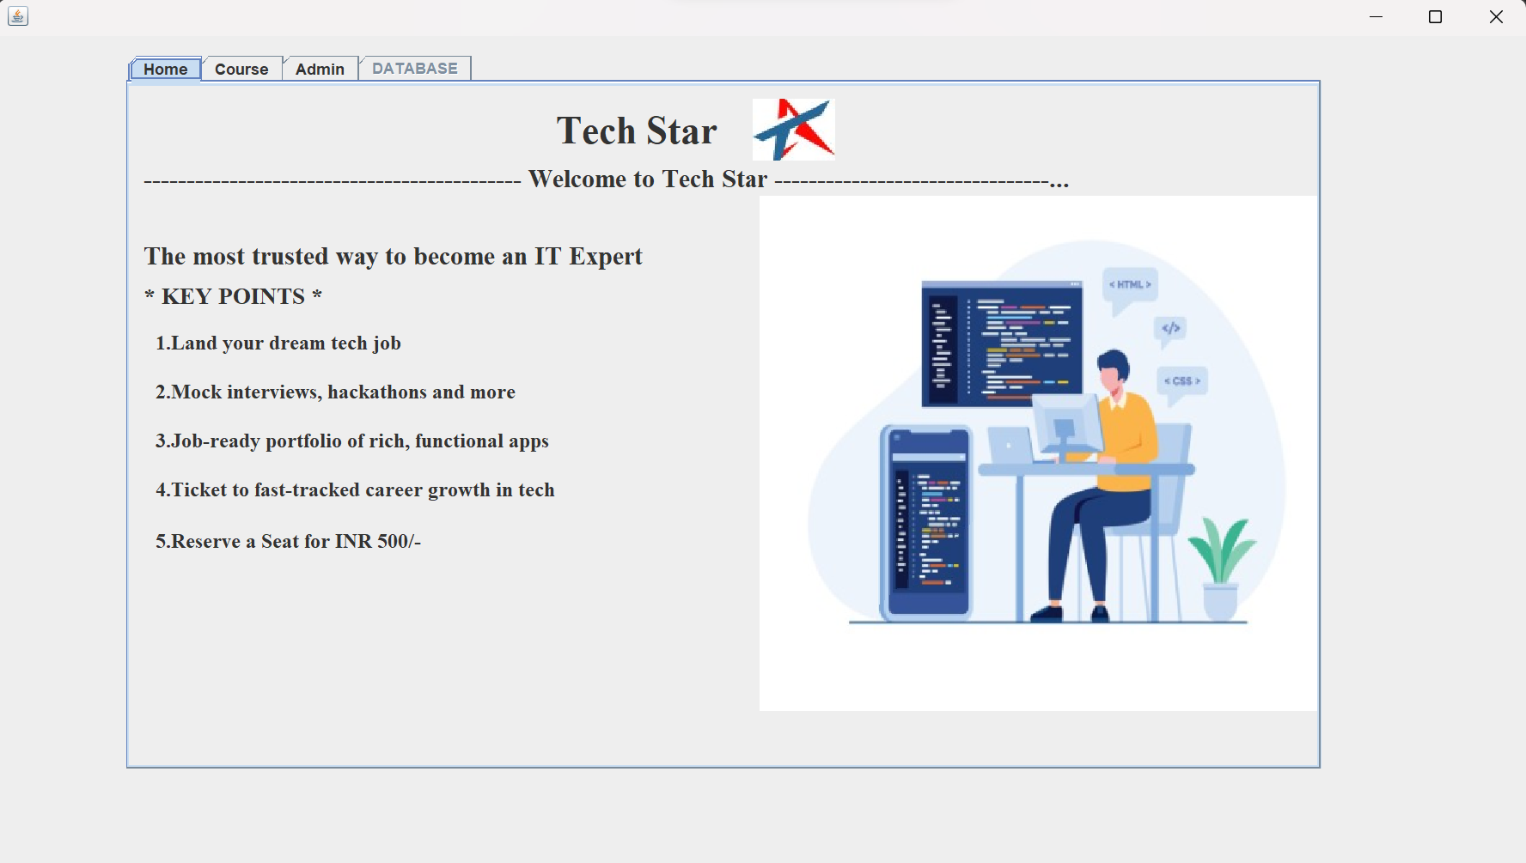

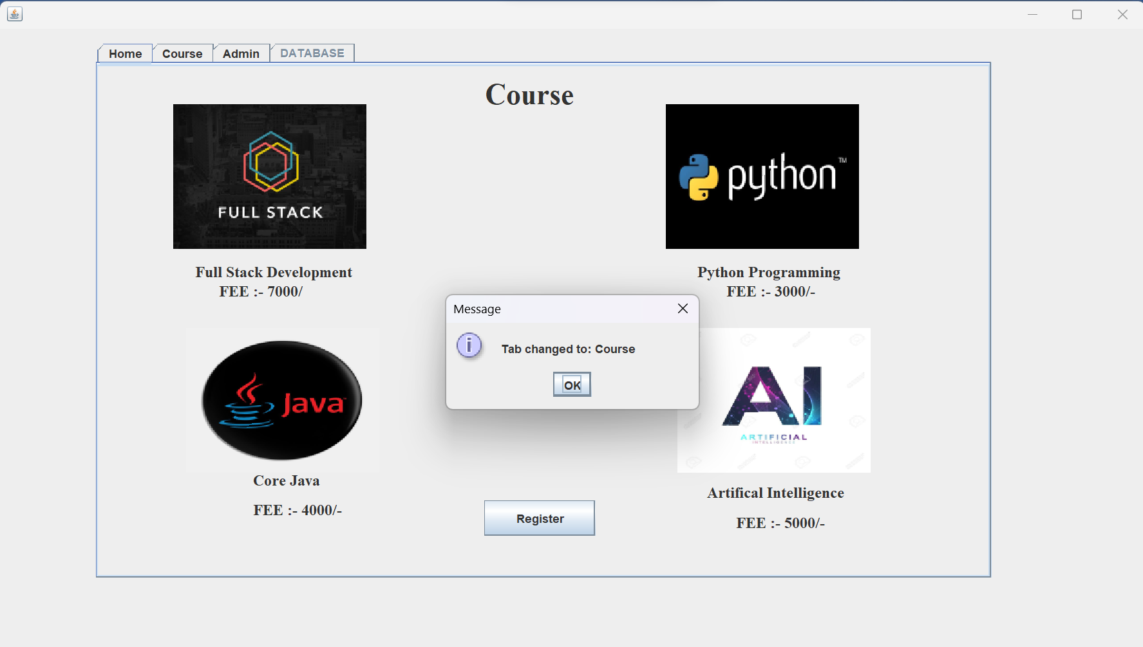

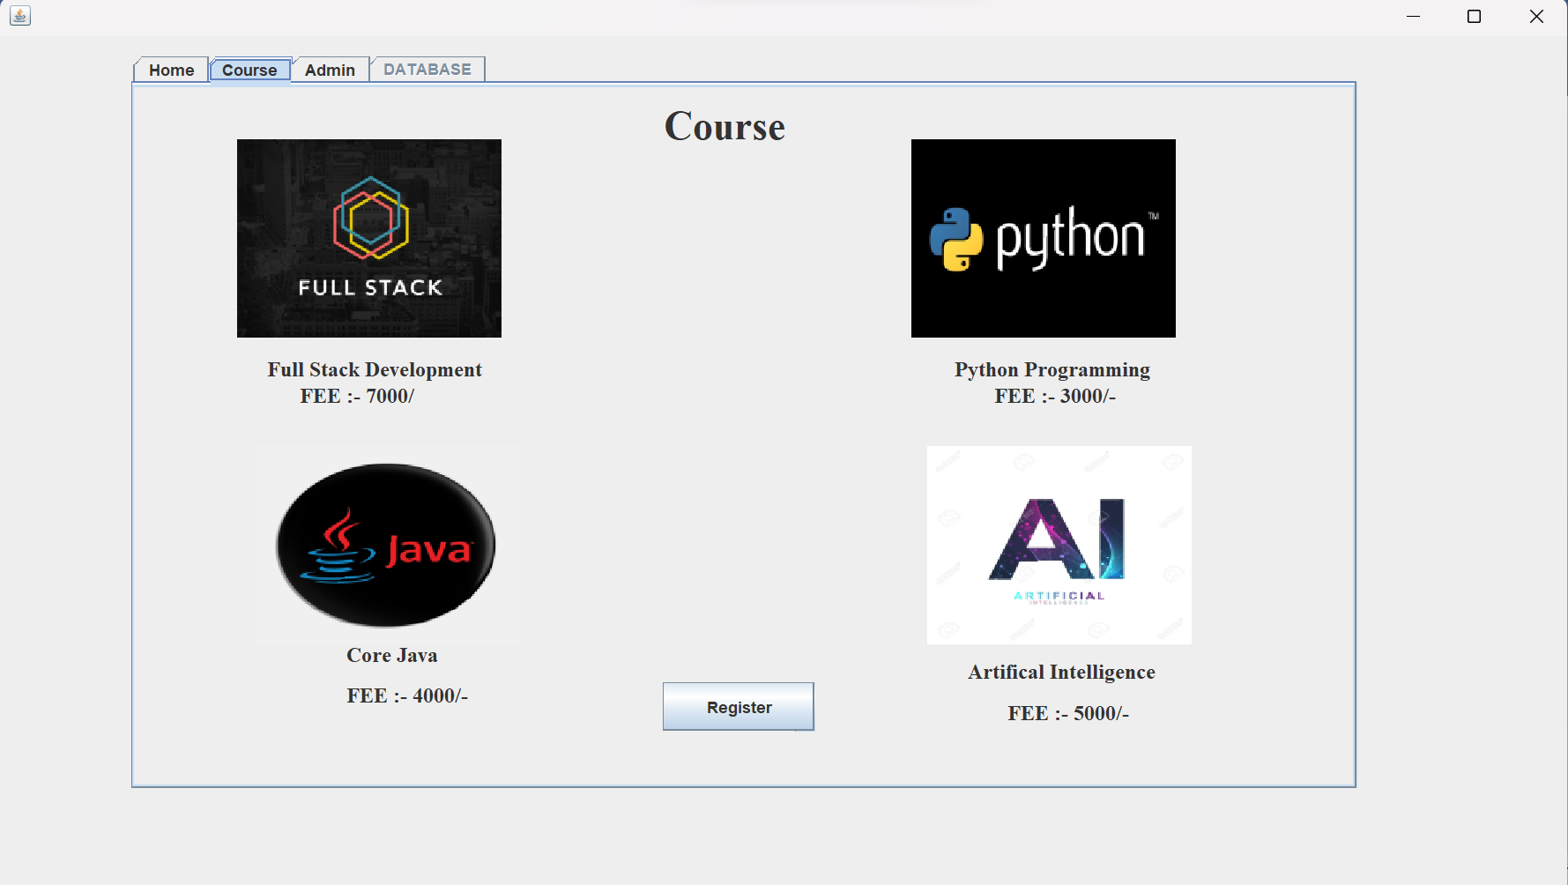

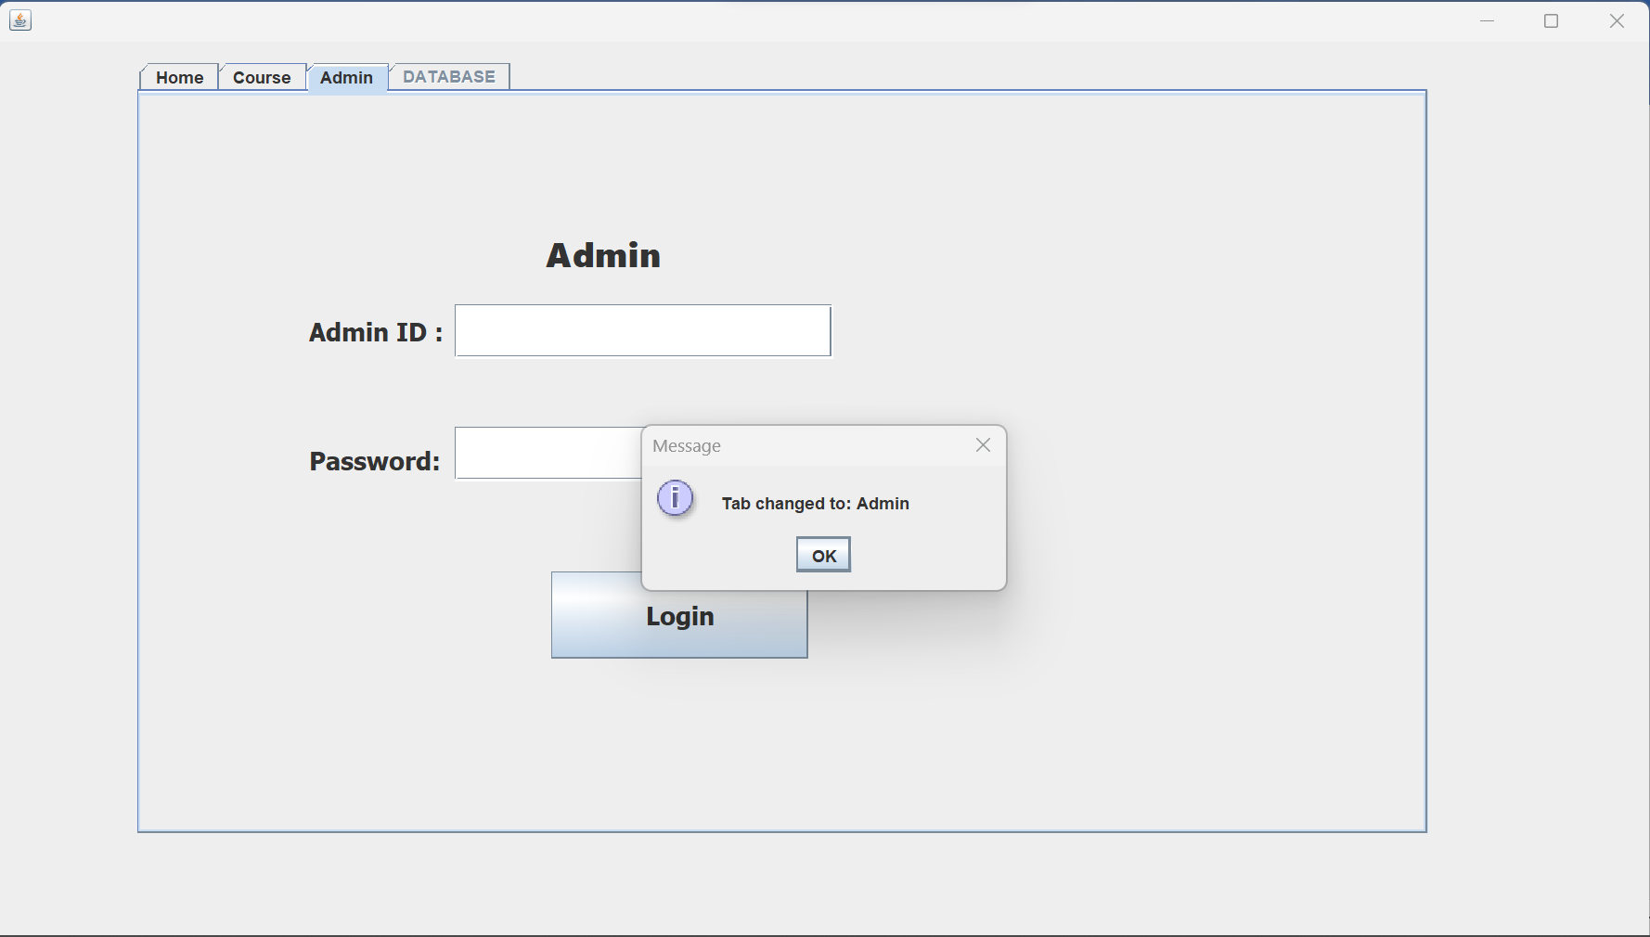

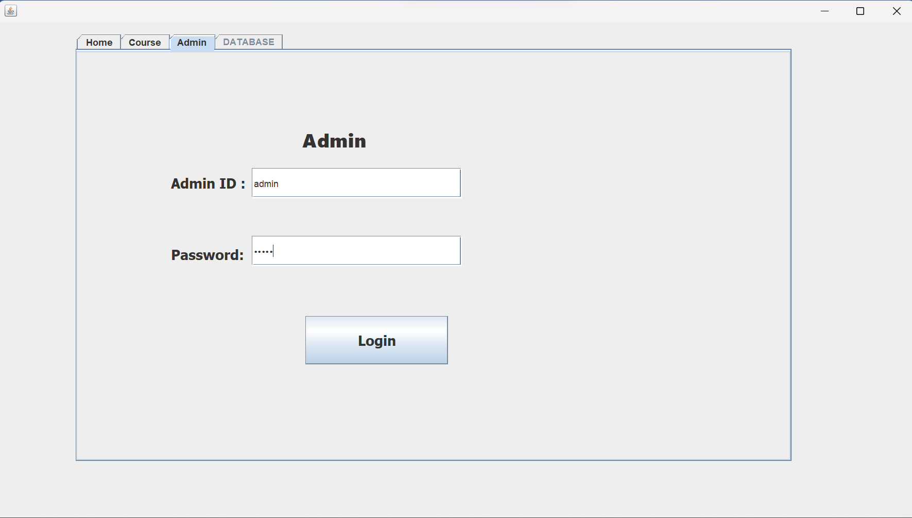

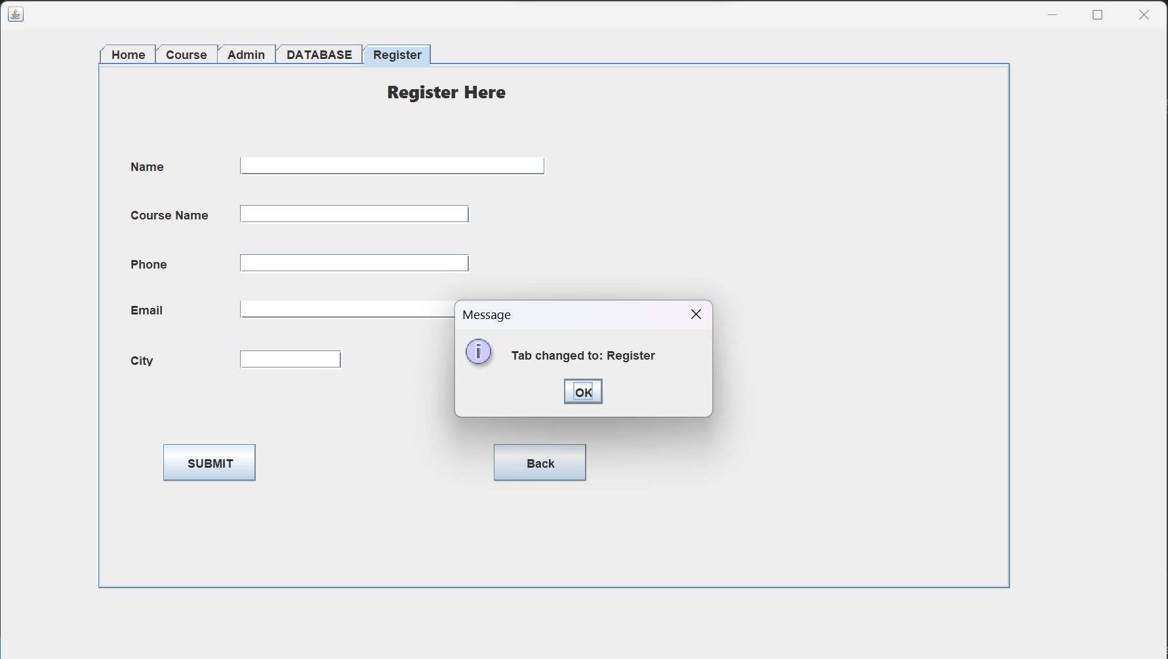

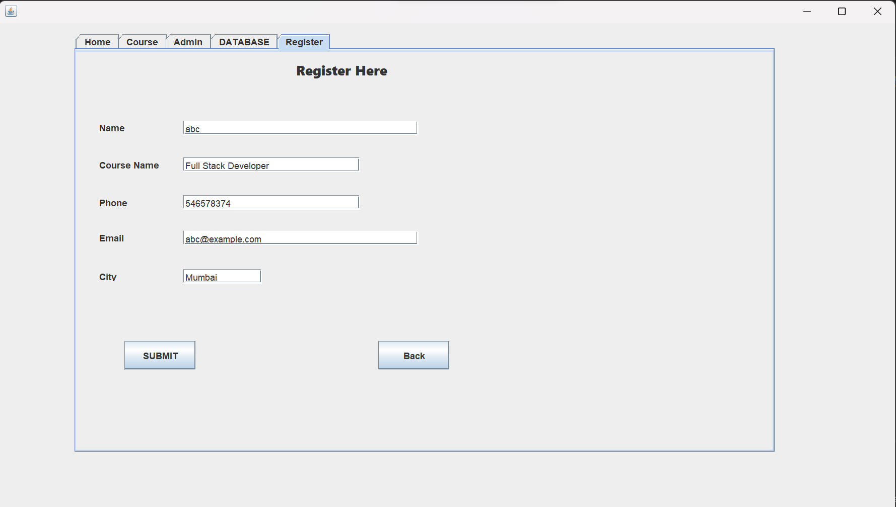

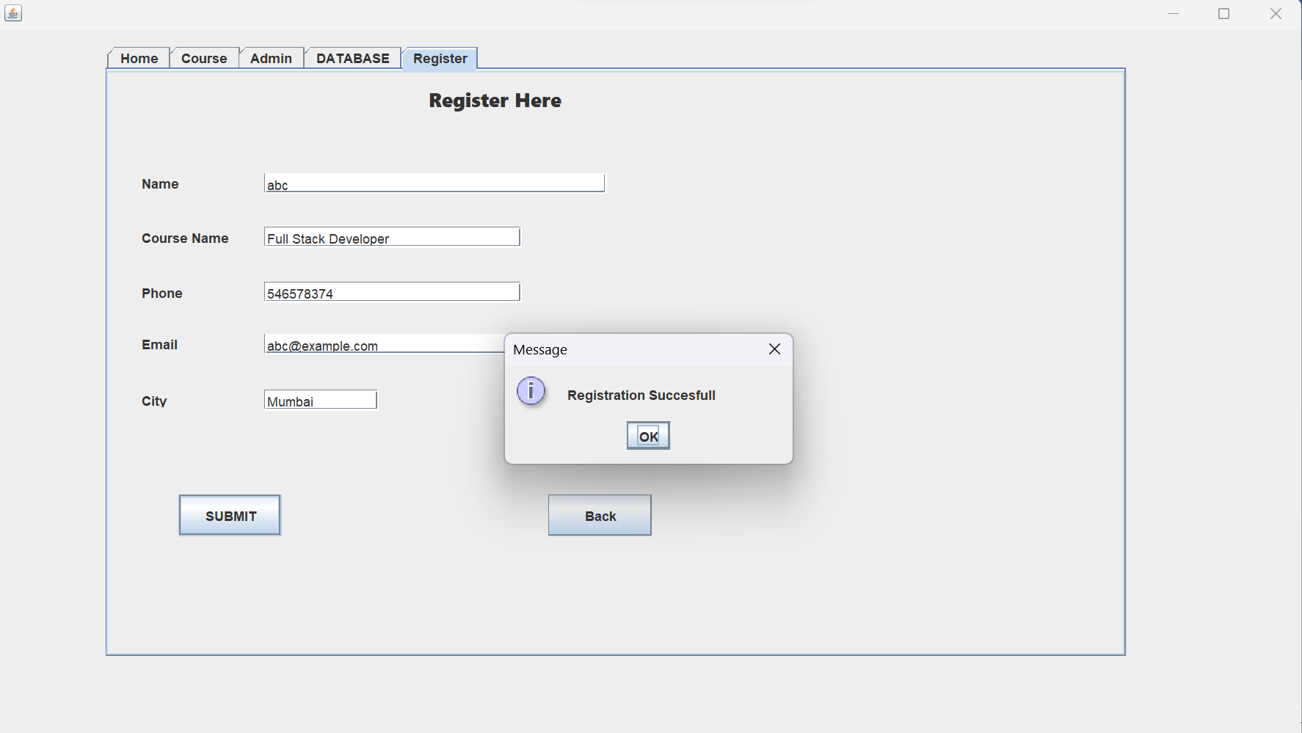

When we press Back Button back to Course Tab

